Phase 2: Core Infrastructure & Networking - Build Your Backbone
Objective: This phase focuses on establishing the essential network services that form the foundation of any robust IT environment. We've deployed a central identity management system (Active Directory), configured automatic IP assignment (DHCP), and set up name resolution (DNS). Crucially, we've also gained practical experience in diagnosing and resolving common network connectivity issues.

1. Active Directory Domain Services (AD DS) Deployment (DC01)
Summary: DC01 was transformed into our primary domain controller, becoming the central hub for user authentication, resource management, and policy enforcement within our lab environment. This involved assigning it a static IP, installing the AD DS role, and promoting it to a domain controller by creating a new Active Directory forest.
1.1. Static IP Configuration (DC01)
- Action: Assigned a static IP address of 192.168.1.1 with a 255.255.255.0 subnet mask to the IT_Lab_Network adapter on DC01, setting its Preferred DNS server to 127.0.0.1 (localhost).
- Outcome: Ensured DC01 has a stable and predictable network address, essential for its role as a domain controller and DNS server.
1.2. Install AD DS Role
- Action: Installed the Active Directory Domain Services role on DC01 using Server Manager's Add Roles and Features Wizard.
- Outcome: Prepared DC01 to be promoted to a domain controller, adding the necessary binaries and components for AD DS functionality.
1.3. Promote to Domain Controller
- Action: Utilized the post-deployment configuration wizard to promote DC01 to a domain controller, establishing a new Active Directory forest named yourdomain.local and setting the DSRM password.
- Outcome: Successfully created the Active Directory domain, making DC01 the authoritative server for authentication and directory services within yourdomain.local.

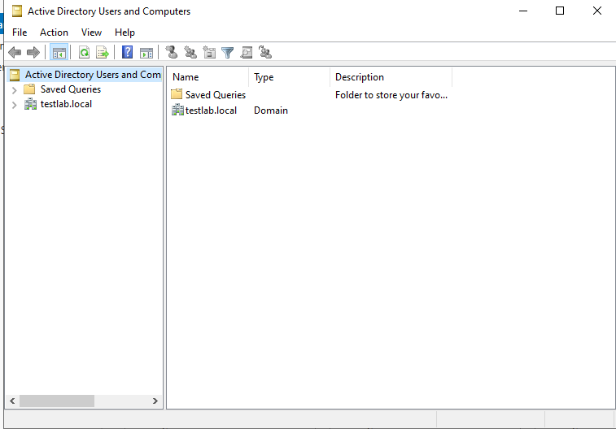

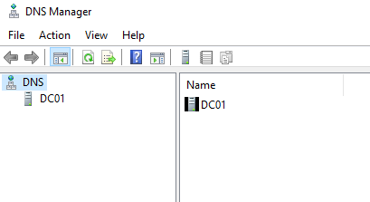
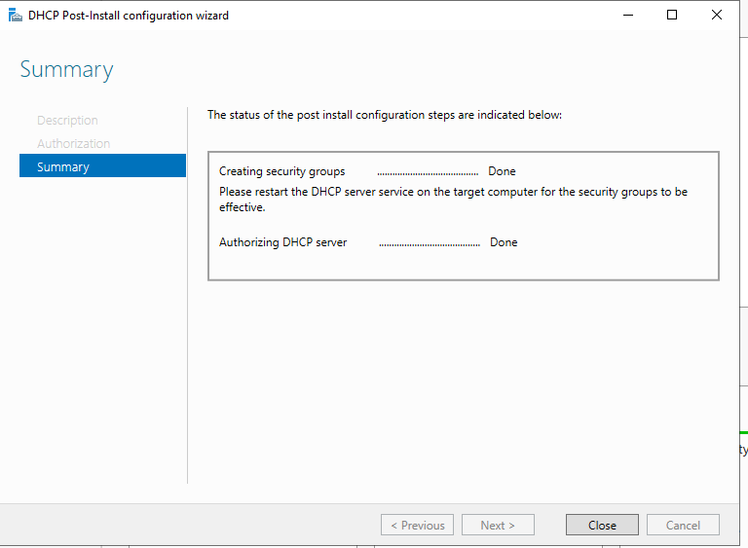

2. DHCP & DNS Configuration (DC01)
Summary: DC01 was further configured to provide essential network services: Dynamic Host Configuration Protocol (DHCP) for automatic IP assignment and Domain Name System (DNS) for name resolution, ensuring seamless communication within our new domain.
2.1. Install DHCP Role
- Action: Installed the DHCP Server role on DC01 through Server Manager.
- Outcome: Enabled DC01 to distribute IP addresses and network configuration details to client machines on the IT_Lab_Network.
2.2. Configure DHCP Scope
- Action: Configured a new DHCP scope on DC01, defining the IP address range from 192.168.1.100 to 192.168.1.200 and including 192.168.1.1 as the DNS server option for clients.
- Outcome: Automated the IP addressing for clients, ensuring they receive valid IPs and correctly point to our domain controller for DNS resolution.
2.3. DNS Basics
- Action: Verified the existence and correct configuration of the yourdomain.local Forward Lookup Zone in DNS Manager, confirming DC01's A record (192.168.1.1) was present.
- Outcome: Confirmed that DC01's DNS server is correctly configured to resolve names within our domain, a critical component for Active Directory functionality.

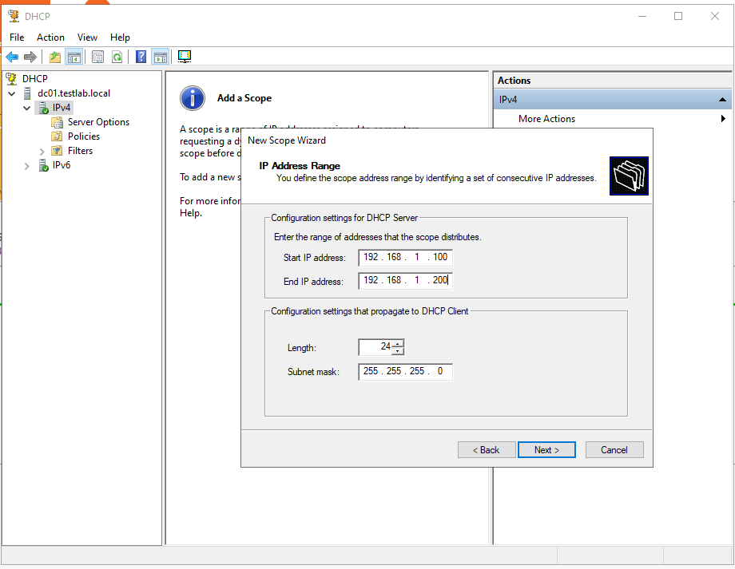
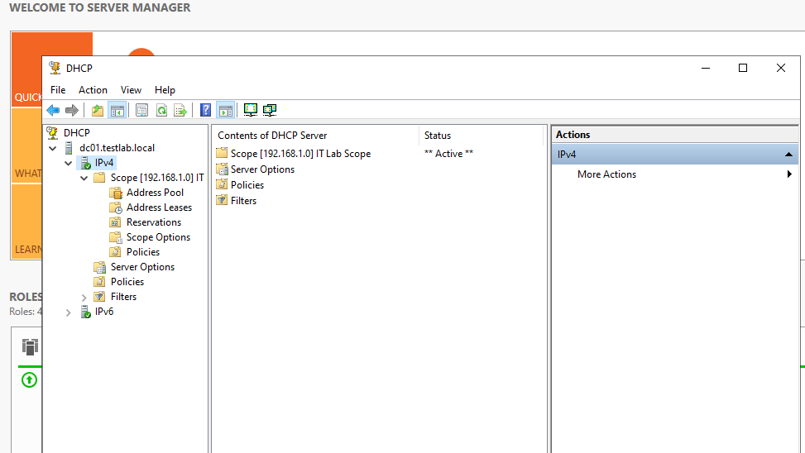

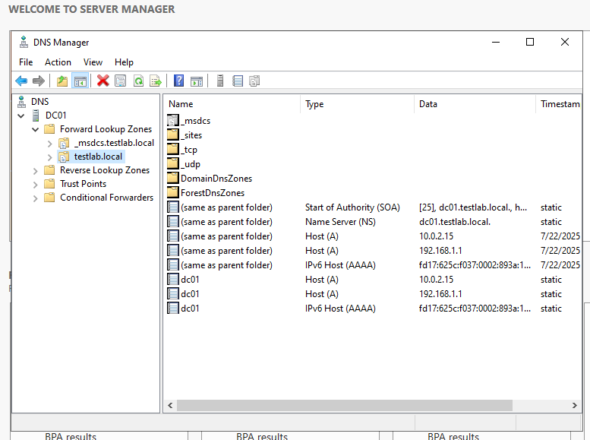
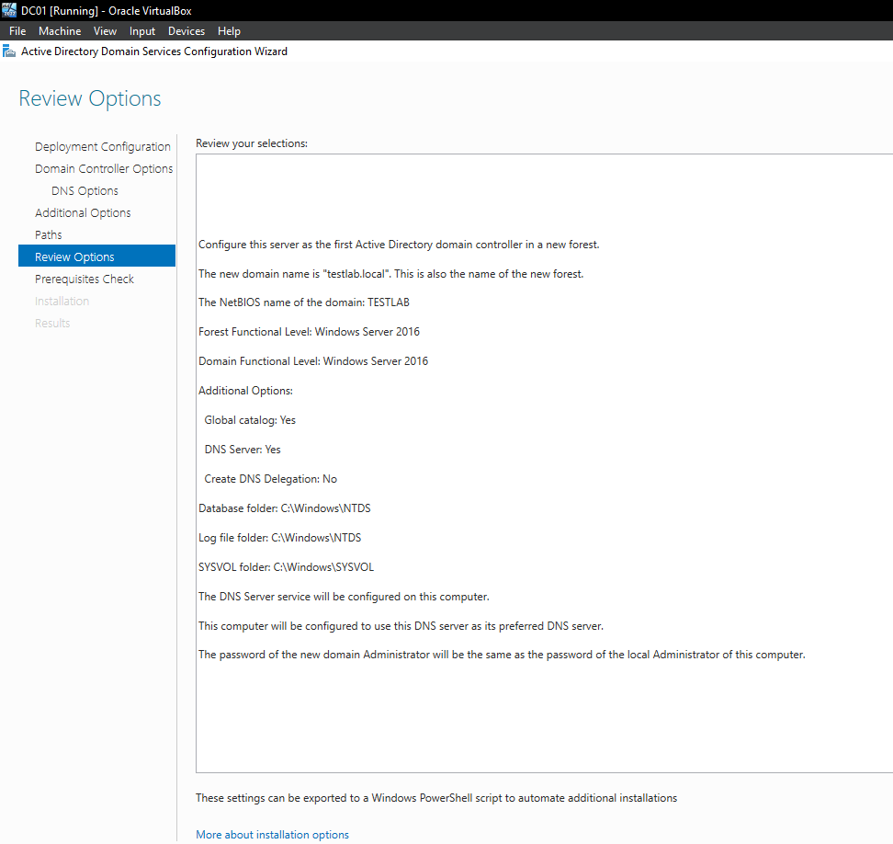
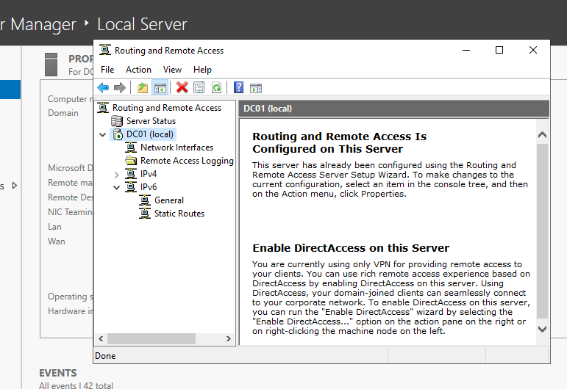
3. Client Domain Join & Network Configuration
Summary: Our client machines, W10-Client01 and Ubuntu-Client01, were integrated into the IT_Lab_Network. W10-Client01 was successfully joined to the Active Directory domain, demonstrating the core functionality of our identity management system.
3.1. W10-Client01
- Action: Configured W10-Client01's IT_Lab_Network adapter to obtain IP and DNS settings automatically via DHCP. Subsequently, joined W10-Client01 to yourdomain.local using domain administrator credentials.
- Outcome: W10-Client01 successfully received an IP address from DC01's DHCP server, resolved DNS via DC01, and was formally added as a member of the Active Directory domain, demonstrating successful integration.
3.2. Ubuntu-Client01
- Action: Configured Ubuntu-Client01's network adapter to obtain its IP address via DHCP from DC01.
- Outcome: Ubuntu-Client01 successfully acquired an IP address and DNS settings from the DHCP server on DC01, establishing network connectivity within the lab. (Optional: Researched and attempted to join Ubuntu to the Active Directory domain using realmd or Samba, demonstrating advanced integration skills.)

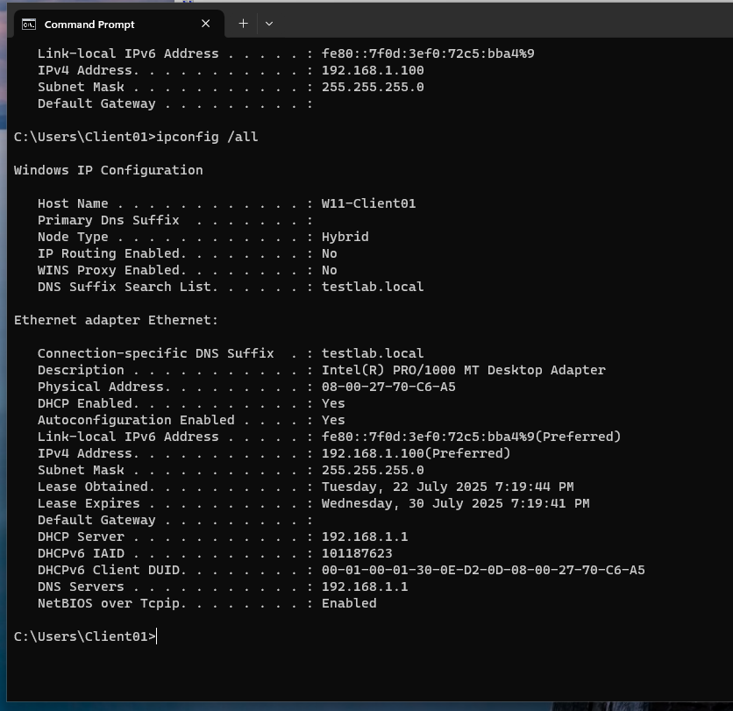

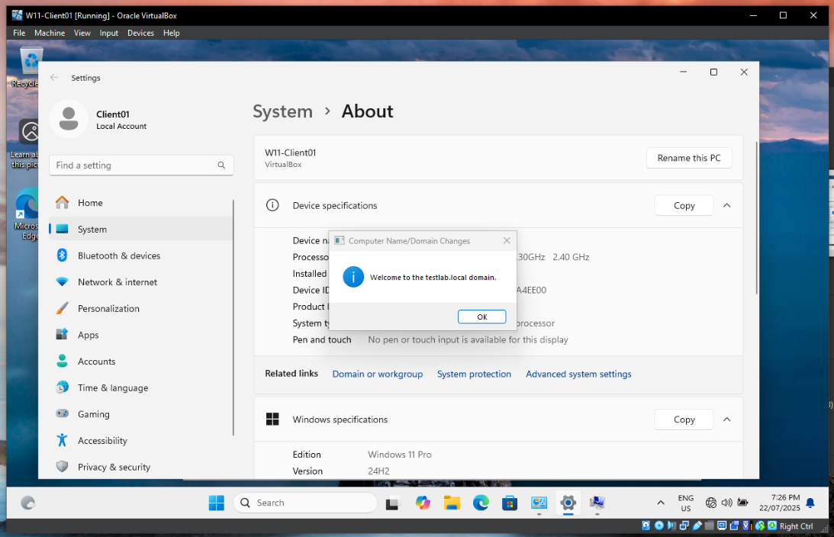
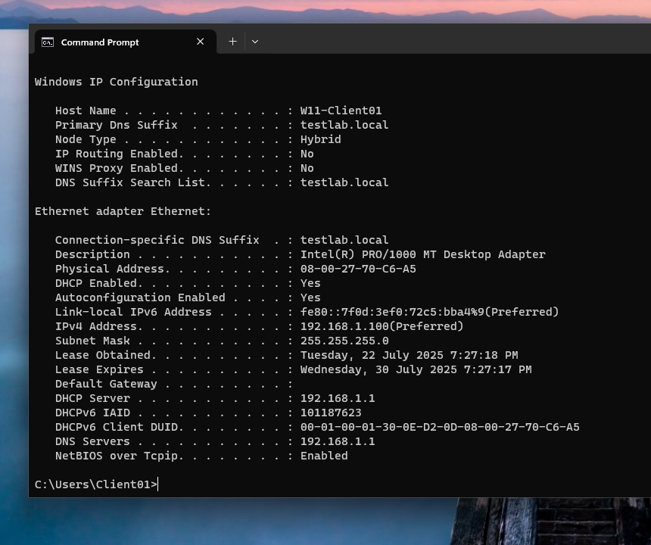
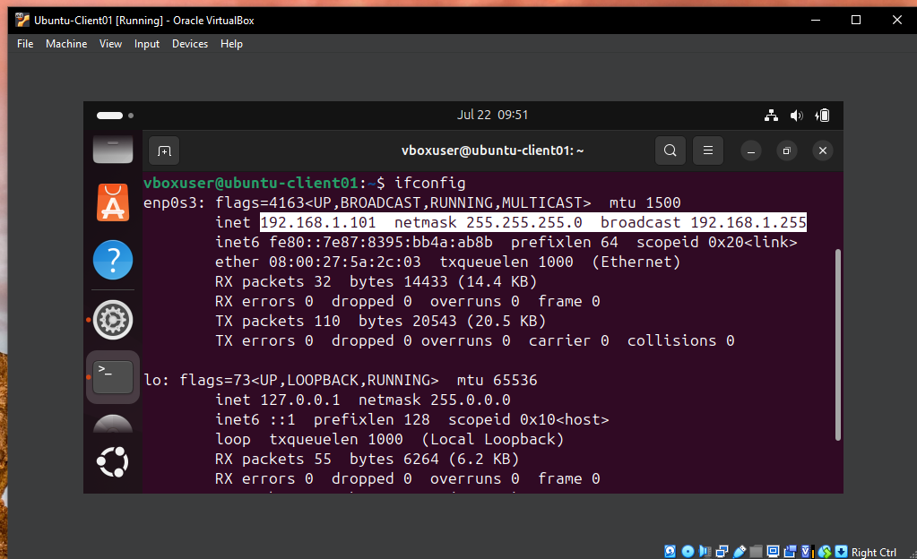

4. Core Networking Troubleshooting
Summary: This section provided hands-on experience with fundamental networking tools and scenarios. By simulating common network issues, we practiced systematic diagnosis and resolution, reinforcing our understanding of IP addressing, routing, and DNS.
4.1. Tools Practice
- Action: Extensively used ipconfig/ifconfig, ping, tracert/traceroute, nslookup, and netstat on both W10-Client01 and Ubuntu-Client01.
- Outcome: Developed proficiency in using command-line tools to inspect network configurations, test connectivity, trace network paths, query DNS, and analyze active network connections.
